**CREDENTIALS ON HEADERS ANGULAR 4 - CORS EXPRESS**

REF:

<https://scotch.io/tutorials/authenticate-a-node-js-api-with-json-web-tokens>

<https://vinaygopinath.me/blog/tech/enable-cors-with-pre-flight/>

IN ORDER TO REACH THIS, WE HAVE TO CONFIGURE CORS ON EXPRESS SERVER TO ALLOW ***PREFLIGHT REQUESTS***

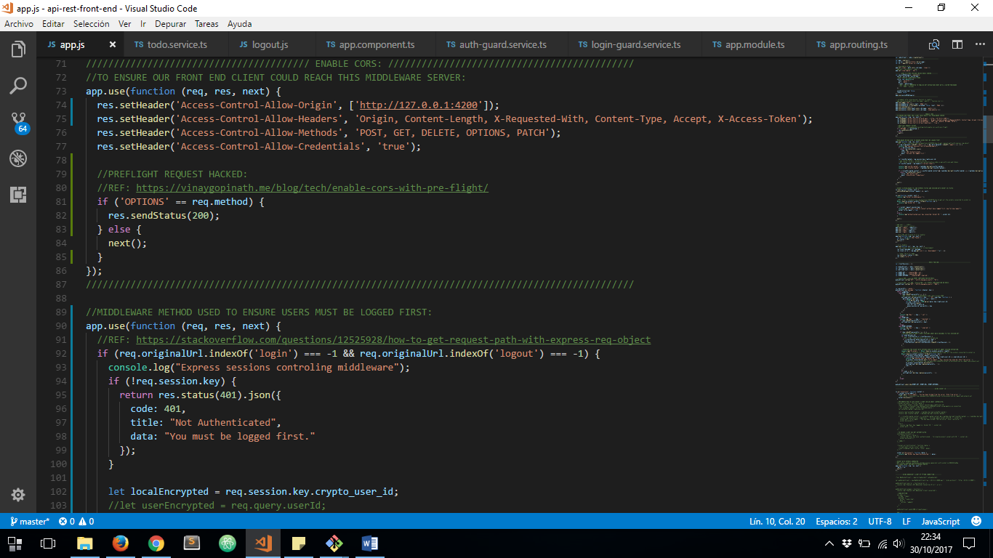

THEN WE’LL BE ABLE TO SPECIFY ***x-access-token*** HEADER TO SEND USER CREDENTIALS ON EACH REQUEST INSTEAD OF SENDING THEM ON URL:

